Chapter 3-[Proofs](https://mfleck.cs.illinois.edu/building-blocks/version-1.3/proofs.pdf)

Tuesday, December 27, 2022

1:34 AM

**Proofs:**

Simplest way to prove a claim with the below form: Pick a value and plug it in



Example:



Define "Rational":



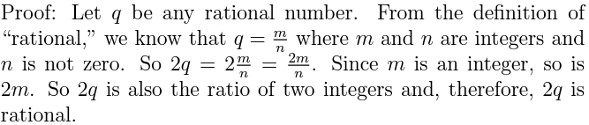

(first expand the word "rational" into its definition, then at the end go the other way)

***Definitions are always intended to work in both directions.***

(So use iff instead of if)

***Collect up all your given information right at the start of the proof, so you know what you have to work with.***

Example 2:





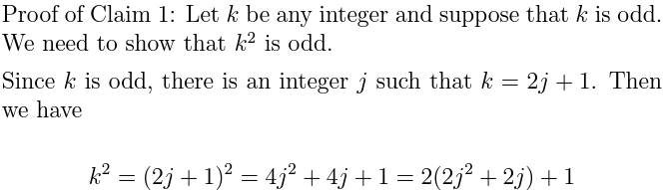

Since j is an integer, 2j2 + 2j is also an integer. Let's call it m. Then k2 = 2m + 1. So, by the definition of odd, k2 is odd.

*(The new variable used at the end of the proof-m-matches the definition, which helps keep the proof organized)*

***Existential Statement Proofs:***

Easiest way is to list specific examples:





*(Do NOT go for an overkill and write out a long general statement/argument proof, an example is enough)*

*(unless you have too much time left on the exam)*

***Disproving a Universal Claim:***

Come up with an existential statement proof (a case in which the claim is false), see above.

***Disproving an Existential Statement:***

Come up with a universal statement proof (in which the claim is false)

**Summary:**

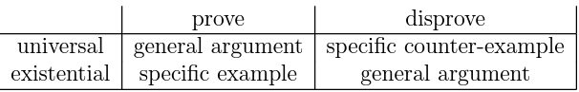

It’s important to use a fresh variable name each time you expand a definition. (even if it is the same definition)

Q.E.D. at the end of proof means “what we needed to show.” (Latin), this lets the reader know that the proof has ended.

***Proof by Cases:***

When the claim that needs to be proven has an "or" in it, do part of the proof two or more times, once for each of the possibilities in the “or.”

Example:

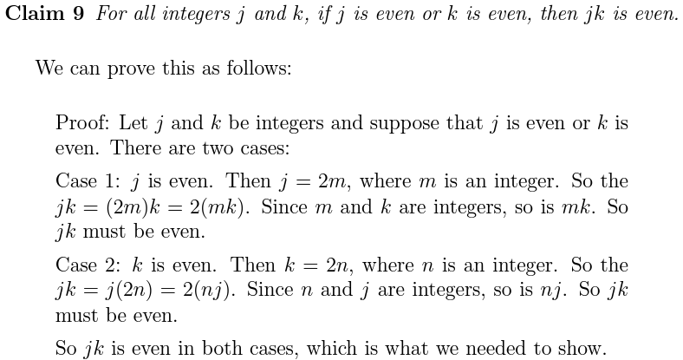

Cases can overlap, but all possibilities have to be covered.

***Rephrasing Claims:***

Turn claim into a convenient form: **a universal if/then statement whose hypothesis contains positive (not negated) facts.**

Turn claim into contrapositive: **by negating the conclusion of the original claim, we gain access to the basic quantities to help us prove the derived quantity that was originally on the "if" side.**

